Connect 2 Loan System

To Create an Advanced Booking

To create a booking for an item select the ‘Book by Category’ tab. Search for an item in the search field or use the category list on the left-hand side to filter the type of items you wish to borrow.

For example of you want to borrow a HD CamCorder select “Cameras & Photography”

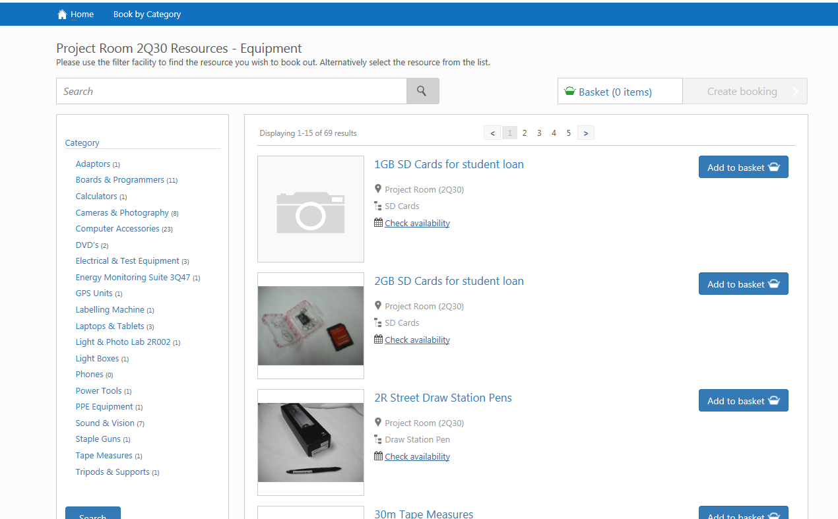

.
This will give you a further break down of categories to select from.

So for example for a HD HandyCam you would need to select “Video Cameras”

You will then get a list of all types of equipment available to borrow within this category.

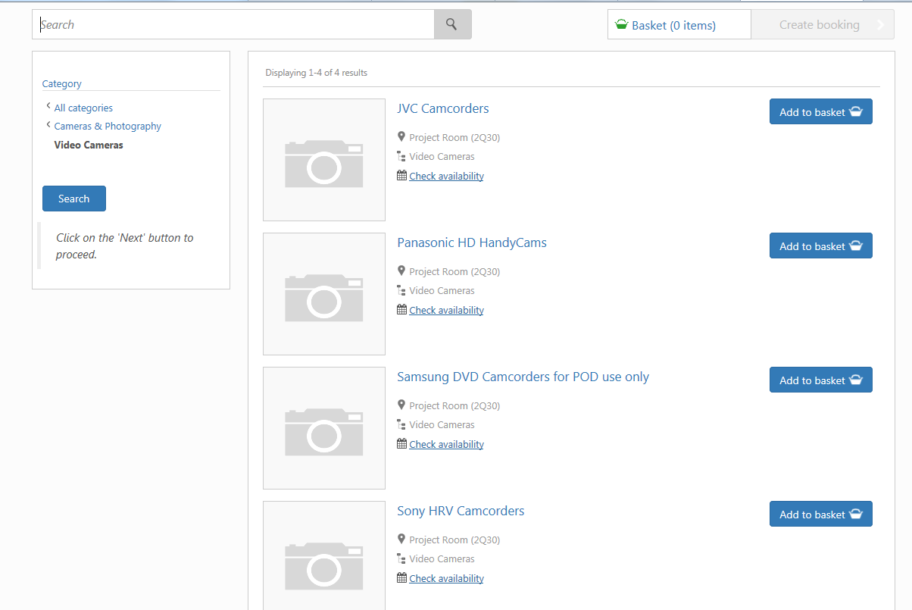

Select the item you wish to borrow by clicking on the ‘add to basket’ icon.

This will then show in your “basket” at the top of the screen.

To book more than one of any itme or to remove from your basket; click on “basket” and alther the quanties. Click ‘update’ once compleate..

Once you are ready click on “create booking”

This link will tell you how long you can book the selected item for.
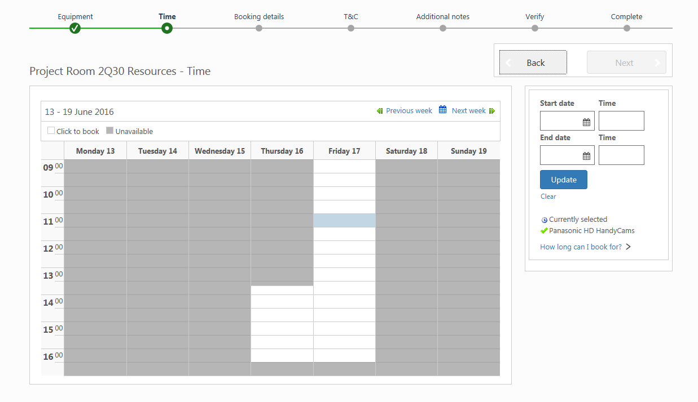

You now need to select when you want your booking to begin from. This can be done by either clicking on the time on the main calendar or by using the calendar selection on the right-hand side of the screen

Once you have selected the time and date you with your loan to begin the loan will automatically default to the maximum loan period allowed for the item.

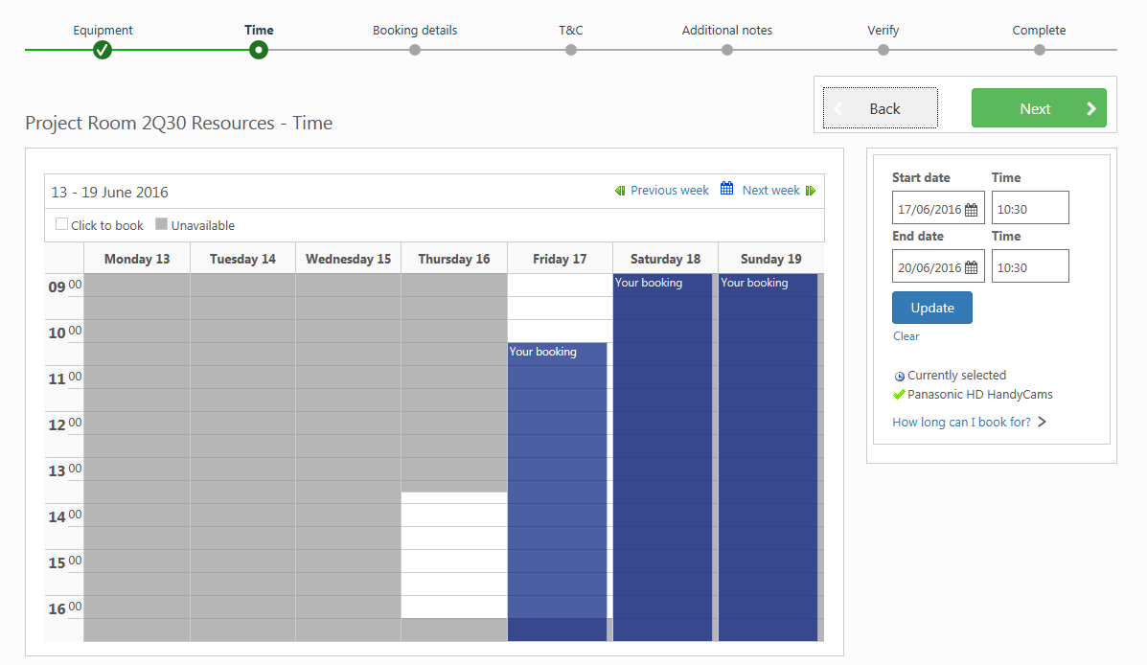

If you don’t collect your items for loan within 2 hours of the time selected, your loan will automatically be removed from the system – so please select your time for collection carefully!

Click ‘Next’ to proceed.

You will then be required to provide us with information on why you need the equipment – a brief explation will do.

You will also be required to provide an e-mail adress – this will be the e-mail we will use to sent any deteils regarding your booking. You can use either your UWE e-mail or a personal one; which ever you use the most!

Once you have supplied these details please click ‘Next’ to continue.
This takes you to a Terms and Conditions page. Please read these and click in the tick box to continue.

This next page allows you to provide any extra information on your loan. For example you were hoping to borrow a lead which isn’t on the system or you wanted to borrow the items for longer than the loan period allows – You will not be able to book this out yourself but a request can be submited via the Project Room Desk by compleating a ‘Long Term Loan’ form. Please vist the Project Room Desk for more information

The final pages give an overview of your loan. Please check these details carefully to ensure they are correct and click ‘submit’ when you are ready.

A confirmation screen will show that the booking is complete and an e-mail with the booking details will be sent to the e-mail provided.

Your loan will not be secured until you have reached this page.

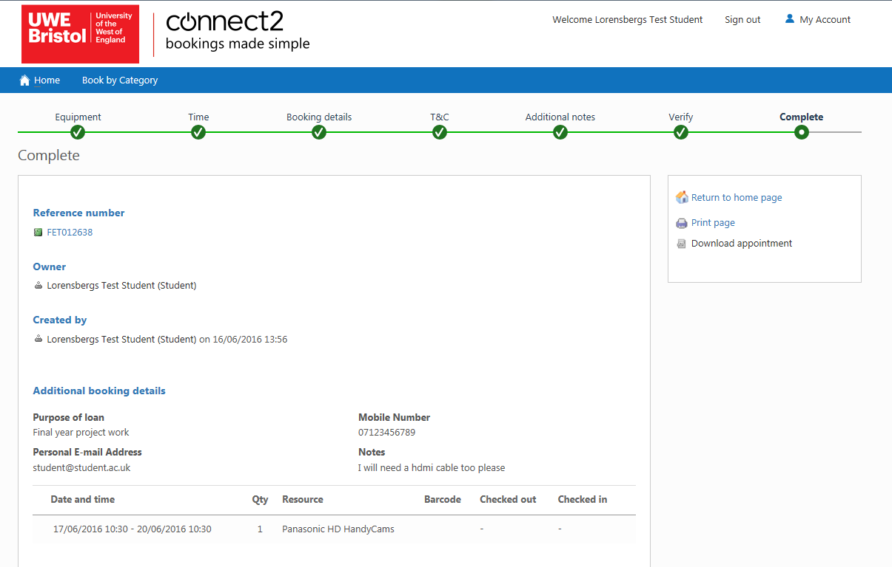

Booking Complete!

Don’t forget to collect your items for loan from the Project Room on the date and time you have selected otherwise you reservation may not be guaranteed.

